Synopsis:-

* Introduction:-

All living organisms must always have blood on hand in case of need. There are many electronic blood donation centres to help in communication between blood donors and medical establishments. There are no online blood donation services that allow for direct communication with the recipient. This is the system’s true flaw at the moment. The current frameworks need a lot of time, money, and labour. The innovative concepts could improve blood banks that already exist and facilitate the shift from traditional desktop to portable architecture. The remainder of the proposed study addresses various aspects of the elements of the improved framework, such as the data being kept, data for future applications, and the various blood group kinds being given and received.

* Motivation:- Our blood bank application makes the process of reaching out to potential blood donors easy and encourages people to become voluntary donors. Blood Donors can see their influence and create blood donation awareness to save multiple lives.
* Problem definition:- The problem definition of the system is to launch an online interaction medium for the blood donation management. 2The main aim of this project is to help the people who needs blood in emergency and to associate some donors who are willing to donate their blood to needy people and save their lives.

Architecture:-

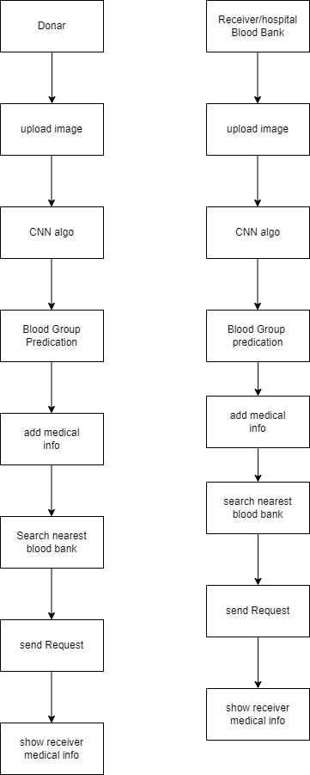

* References:-
* 1. Javed Akhtar Khan and M.R. Alony, ”A New Concept of Blood Bank Management System using Cloud Computing for Rural Area,” International Journal of Electrical, Electronics ISSN No. (Online): 2277-2626 and Computer Engineering 4(1): 20- 26(2015).
* 2. T.Hilda Jenipha and R.Backiyalakshmi, ”Android Blood Donor Life Saving Application in Cloud Computing,” American Journal of Engineering Research (AJER) 2014.
* 3. Sagar Shrinivas, Vasaikar Vijay and Suresh Yennam, ”Online Blood Bank Using Cloud Computing,” International Journal of Advanced Research, Ideas and Innovation In Technology,(volume 3, Issue 1)
* 4. P. Priya, V. Saranya, S. Shabana and Kavitha Subramani, ”The Optimization of Blood Donor Information and Management System by Technopedia,” International Journal of Innovative Research in Science, Engineering and Technology An ISO 3297: 2007 Certified Organization, Volume 3, Special Issue 1,2014.
* 5. Siva Shanmuga and N. Ch. S. N. Iyengar, ”A Smart Application on CloudBased Blood Bank,” Journal of Computer and Mathematical Sciences, Vol.7 (11), 576-583, November 2016.